Name: _____________________ Class:__________ Date:__________
Instructions: Write answers in the right-hand column. Score: ___________ / 45 marks
Section A— Multiple choice (10 marks)

 | Which of the following is NOT an SI unit?  - m/s²  - s  - km/s  - kg/m | C | 1
 | What distance would a cockroach, crawling at a speed of 1.5 centimetres per second, cover in an hour?  - 5400 m  - 5.4 m  - 54 m  - 0.54 m | C | 1
 | A train travels at a speed of 18 m/s. This is equivalent to a speed of:  A 5 km/h  B 64.8 km/h  C 64 800 km/h  D 0.005 km/h | B | 1
 | Inertia can be defined as:  A the amount of matter in an object  B a tendency of an object to resist a change in its motion  C the force of gravity on an object  D when a force makes something move | B | 1
 | Which one of the following statements about friction is INCORRECT?  A Friction operates in the same direction as a moving object.  B Friction is a contact force.  C Friction between two moving objects produces heat.  D Without friction you could not grip an object or walk. | a | 1
 | Mai has a mass of 45 kg. On Planet Zulptor she weighs 351 N. The acceleration due to gravity on Planet Zulptor is:  A less than that on Earth  B the same as that on Earth  C greater than that on Earth  D unable to be determined | A | 1
 | A 90 N force is applied to a 65 kg mass. The mass will accelerate at:  A 0.72 m/s²  B 1.2 m/s²  C 1.4 m/s²  D 5.9 m/s² | C | 1
 | A skydiver glides to the ground at a steady speed of 7 metres per second. Which statement below best describes what is happening?  - The upward force of air resistance acting on the skydiver is smaller than the downward weight force that is acting  - The upward force of air resistance that is acting on the skydiver is larger than the size of the downwards weight force  - The upward force of air resistance balances the downwards force of gravity acting on the skydiver  - The weight force that acts on the skydiver is larger than the upwards force of air resistance | C | 1
9 | Which of the following is best explained by Newton’s third law?  - Unbelted passengers will be thrown forward when a car stops suddenly.  - A gun recoils when a shot is fired.  - The acceleration of an object when a force is applied depends on the mass of the object.  - The weight of an object varies from planet to planet. | B | 1
100 | Which of the following best describes the energy changes occurring when an apple falls from a falls from a tree branch to the ground below?  - gravitational potential → kinetic → heat  - elastic potential → kinetic → heat  - gravitational potential → heat → kinetic  - elastic potential → heat → kinetic | A | 1
Section B— Short answer (25 marks)

- ` | Calculate the average speed (in m/s) of  - Brendan, who runs 882 metres in 4.2 minutes  - A gazelle that runs  10 kilometres in 7.5 minutes.  Show full working in your answers. | - v = s/t  v = 882/ 4.2 × 60  = 3.5 m/s  - v = s/t  = 10 × 1000/ 7.5 × 60  = 22.2 m/s | 2
 | Calculate the distance (in km) travelled by:  - a communications satellite moving around the Earth at a speed of 3100 m/s for one day  - Su-Lin, after walking at a speed of 1 m/s for 45 minutes.  Show full working in your answers. | - s = vt  = 3100 × 24 × 60 × 60  = 2.68 × 10⁸ m  = 2.68 × 10⁵ km  - 1 × 45 × 60 = 2700 m  = 2.7 km | 2
 | The school bus slows from 60 km/h to 40 km/h when entering the school zone.  - Calculate the conversion of these speeds from km/h to m/s.  - Given that this change of speed occurred over 8 seconds, calculate the average deceleration of the bus. | a 60 km/h = 60/3.6 m/s  = 16.7 m/s  40 km/h = 40/3.6 m/s  = 11.1 m/s  b Average acceleration = (v – u)/t  = (11.1 – 16.7)/8  = –0.7 m/s²  The average deceleration of the bus is 0.7 m/s². | 3
 | Tina exerts a force of 700 N on a 50 kg crate as shown below.  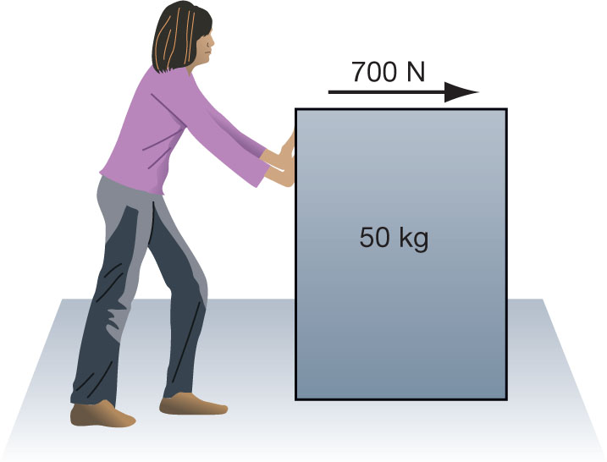  The crate accelerates at 9 m/s².  a Calculate the size of the friction force acting on the crate.  b Demonstrate where this force acts by marking the force using an arrow on the diagram. | a F_{net} = ma = 50 × 9  F_{net} = 450 N  F_{net} = 700 – friction force  = 450 N  So friction force = 100 – 450  = 250 N  b  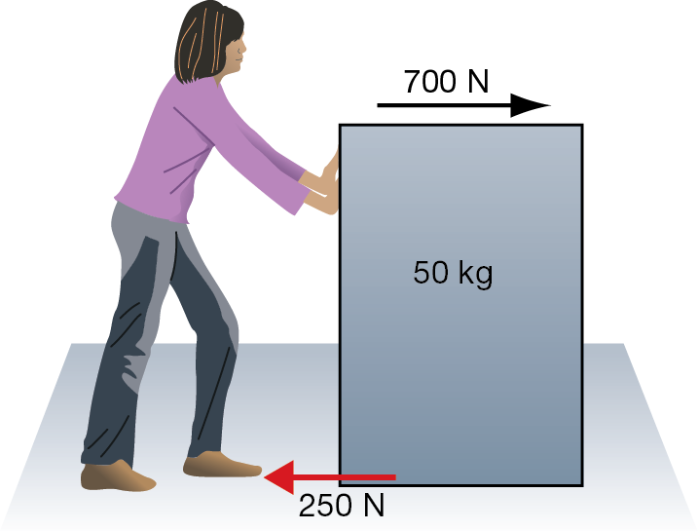 | 2
 | A motorbike starts moving when a traffic light changes green. The table below shows its speed each second.  Calculate the bike’s:  - acceleration during the first 3 s  - acceleration during the final 3 s  - average acceleration for the 5 s.  Show full working in your answers. | - a = (v – u)/t  = (13 – 0)/3  = 4.3 m/s²  - a = (v – u)/t  = (16 – 13)/3  = 1 m/s²  - a = (v – u)/t  = (16 – 0)/5  = 3.2 m/s² | 3
  Time (s) | Speed (m/s)
  0 | 0
  1 | 2
  2 | 8
  3 | 13
  4 | 16
  5 | 16
 | Using the speed–time graph shown below, calculate the:  - distance travelled in the first 3 seconds.  - total distance travelled  - acceleration in the time interval from 4 seconds to 7 seconds.  Show full working in your answers.  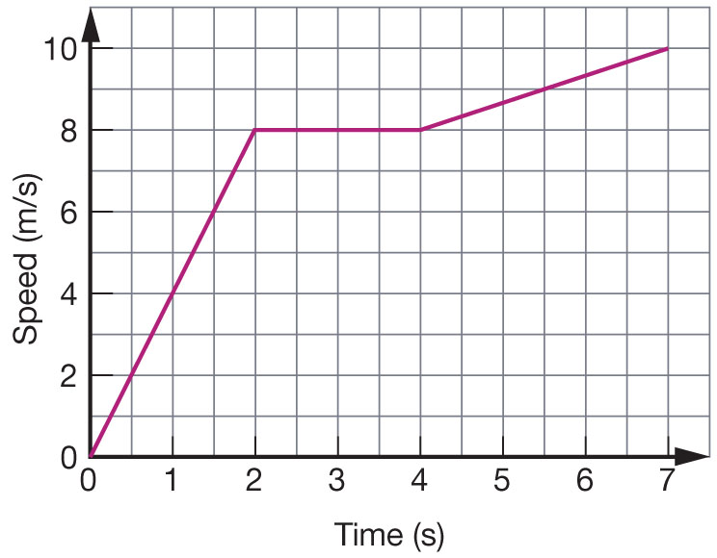 | - The area under the graph is equal to the distance travelled.  Area = area of triangle 0 to 2 seconds + area of rectangle  2 seconds to 3 seconds  Area = 8 + 8  Distance travelled in first 3 seconds is 16 m.  - Area = area of triangle 0 to 2 seconds + area of rectangle  2 seconds to 4 seconds + area of trapezium 4 to 7 seconds  Area = 8 + 16 + 27  = 51  Total distance travelled is 51 metres.  - Acceleration is the slope or gradient of a v–t graph  Slope = vertical rise/horizontal run  = 2/3 = 0.67  The acceleration in the time interval from 4 seconds to  7 seconds is 0.67 m/s². | 5
 | Explain the effect that each of the following changes would have on the acceleration of an object.  - The force acting on an object is tripled.  - The mass of an object is halved, while a constant force is applied. | - Acceleration is tripled.  - Acceleration is doubled. | 2
 | Calculate the kinetic energy of a bullet of mass 50 g that leaves a rifle with a speed of 900 m/s. | KE = mv²  = × 0.050 × (900)²  = 20250 J  (= 20.25 kJ) | 1
 | Calculate the work done when:  - a force of 25 N moves an object through a distance of 8 metres  - a 6 kg object is lifted from a height of 20 metres to a height of 25 metres. (Assume gravitational field strength is 9.8 N/kg.)  Show full working in your answers. | - Work = Fs  = 25 × 8  = 200 J  - Work is done against the weight force.  W = Fs  = 6 × 9.8 × 5  = 294 J | 2
10 | A cannonball of mass 5 kg is dropped from a height of 12 metres off a cliff.  Calculate:  - the potential energy of the cannonball before it was dropped. (Assume gravitational field strength is 9.8 N/kg.)  - the speed of the cannonball as it reaches the ground. (Assume that all the potential energy of the object is converted to kinetic energy.)  Show full working in your answers. | - GPE = mgh  = 5 × 9.8 × 12  = 588 J  - KE = mv²  v² = 2 KE/m  = 2 × 588/5  = 235.2  v = 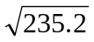  = 15.3 m/s | 3

Section C— Thinking scientifically (10 marks)

1 | An object’s displacement is its position compared to its starting point. It has a size and a direction. A racehorse runs a race that starts and finishes at the same point. If the race was 1000 metres, what was the displacement of the horse when it finished?  - 1000 metres  - 500 metres  - 10 metres  - 0 | D | 1
2 | The racehorse now runs a second race but is unable to finish due to a sore leg and stops to a halt at a distance of 120 m east of the finish line. Given that the distance to be run in the race was 1000 m, and that the finish line was where the race started, the displacement of the racehorse is now:  - 120 m east  - 120 m west  - 880 m east  - 880 m west | A | 1
3 | Shown below is a displacement–time graph for Bob as he walks to a friend’s house and returns over a day. Which of the following statements concerning this journey is correct?  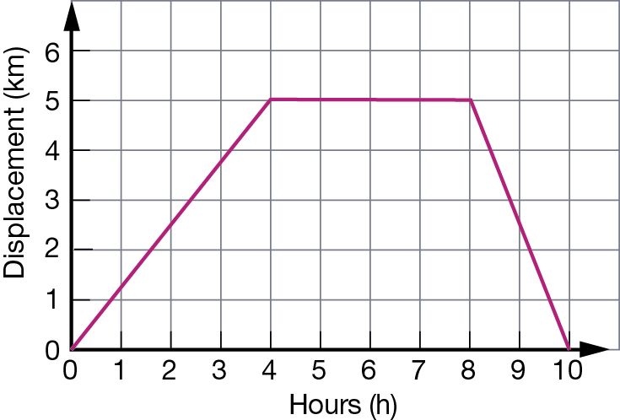  A The total distance travelled for the journey was 5 km.  B The total distance travelled for the journey was 10 km.  C The total displacement for the journey was 5 km.  D A one-hour rest break was made during the journey. | B | 1
4 | Refer to the displacement graph in question 3.  Given that Bob’s velocity is the gradient of this graph at any moment, select the correct response from the alternatives below:  A Bob walks faster to his friend’s house than on the way home.  B Bob’s average velocity on the way to his friend’s house was 1 km/h.  C Bob walks faster on the way home than he did when walking to his friend’s house.  D Bob’s average velocity on the way home from his friend’s house was 5 km/h. | C | 1
5 | Three students, Jane, Indira and Charlotte run in a 100 m sprint on a school sports day. The displacement time graph of their motion is shown below.  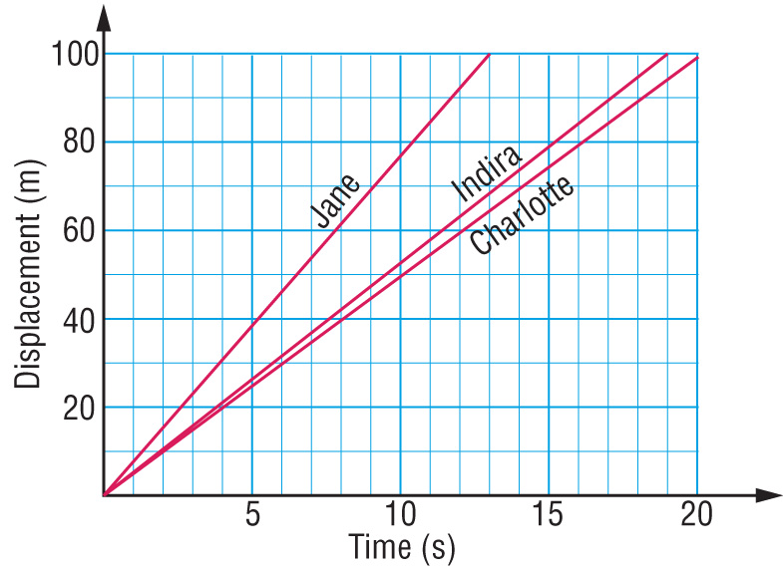  Select the alternative below that correctly orders their finish places in the race.  A Jane wins, Indira is second and Charlotte is third.  B Indira wins, Jane is second and Charlotte is third.  C Charlotte wins, Indira is second and Jane is third.  D Charlotte wins, Jane is second and Indira is third. | A | 1
6 | The motion of three objects, X, Y and Z, is captured using the three ticker tapes shown below.  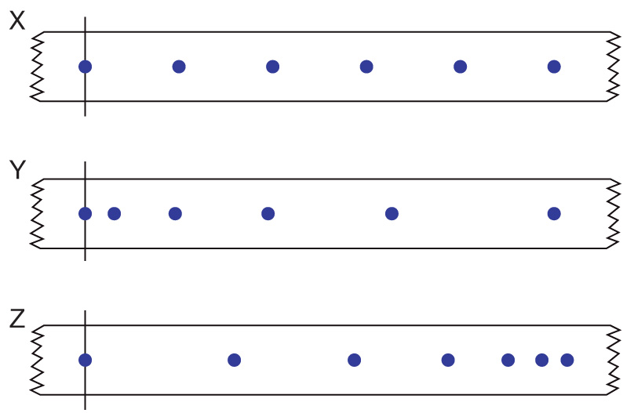  Select the response that best describes the motion of the objects X, Y and Z as described by these sections of ticker tape.  A Object X starts off more slowly than object Y.  B Object X gradually speeds up its motion.  C Object Z starts off with the greatest speed of the three objects.  D Object Y gradually slows its motion. | C | 1
7 | Refer to the sections of ticker tape shown in the previous question.  Identify the graph from the alternatives shown on the axes below that would best represent the motion of each object as captured on the ticker tape.  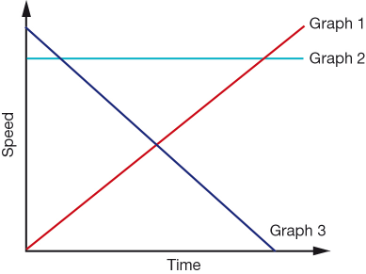 | B | 1
  Options | Motion of Object X is described by graph: | Motion of Object Y is described by graph: | Motion of Object Z  is described by graph:
  A | 3 | 2 | 1
  B | 2 | 1 | 3
  C | 1 | 2 | 3
  D | 1 | 3 | 2
8 | Power is the rate at which energy is supplied. What power is needed to supply 6000 J to lift a teenager 10 m up a vertical cliff face in 5 seconds?  A 1200 J/s  B 120 J/s  C 300 000 J/s  D 30 000 J/s | A | 1
9 | The greater the rebound height of a ball, the greater is the efficiency of energy transfer from gravitational potential to kinetic energy. Five balls are all dropped from a height of 2.0 m. The rebound height of each is listed in the table below:  The type of ball that transferred gravitational potential energy to kinetic energy the most efficiently in this test was the:  A Basketball  B Tennis ball  C Squash ball  D Cricket ball | B | 1
  Type of ball | Rebound height (m)
  Basketball | 1.42
  Tennis ball | 1.55
  Squash ball | 0.05
  Cricket ball | 0.68
10 | The efficiency of a ball is the ratio of the rebound height and the height dropped. Use the table in the previous question to select the likely efficiency of the four balls tested. | D | 1
   | Efficiency of basketball | Efficiency of tennis ball | Efficiency of squash ball | Efficiency of cricket ball
  A | 2.5 % | 34% | 78% | 71%
  B | 78% | 2.5% | 34% | 71%
  C | 34% | 71% | 78% | 2.5%
  D | 71 % | 78% | 2.5% | 34%

